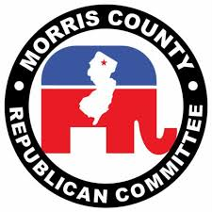

Intention to Present at MCRC Convention for the Morris County Republican Committee Designated Slogan

Name:
Address:
Position:
Email Address:
Phone Number:
Signatures Required (10% County Candidates; 20% Congressional Candidates; 20% Legislative Candidates):

Endorsement Signatures:

Signature

Name, County Committee Town and District

Signature

Name, County Committee Town and District

Signature

Name, County Committee Town and District

Signature

Name, County Committee Town and District

Signature

Name, County Committee Town and District

Signature

Name, County Committee Town and District

Signature

Name, County Committee Town and District

Signature

Name, County Committee Town and District

Signature

Name, County Committee Town and District

